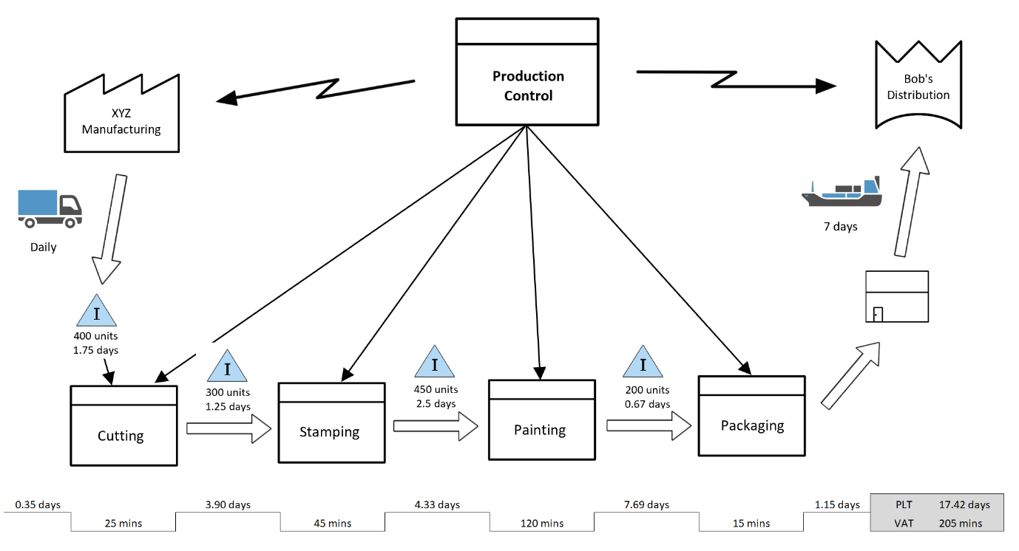

*The value stream shows theoutlook for the manufacturing floor/unit. It gives us an idea of how the planning is done and how the methods are organized. As organizations and companies encounter ever increasing competition and change, it gives us an idea of how the planning is done and how the methods are organized.*

